How can the use of real-life situations be used to understand what people find helpful with behavioral issues through different scenarios?

Criterion A-

This Computer science IA is based on the link between computer science and psychology, the selected client is going to be a clinical psychologist. The client is currently working with an increased number of patients that are demonstrating anxious behaviors / generalized anxiety towards leaving the home to engage in essential community-based activities I.e., shopping for essentials following a period of isolation during the lockdown period. It has been observed that this is due to the patients developing a fear of being in public spaces where there are likely to be large groups of people and a heightened risk of contracting COVID. After consulting with them, I suggested supporting the client by designing a video game to expose patients to retail environments where they are likely to encounter large groups of people. The solution is based on the techniques of exposure therapy which has been demonstrated to reduce anxious behaviors related to agoraphobia. The client needs a product that can effectively use a video game to understand the effects on a person's psychological compass. After the first meeting we discussed, what the focus should be as horror is a wide and general subject, instead look at the psychological problems within people and understand the relation between psychology and video games better. We went over a few types of methods or experimentation that would be useful in solving my problem, Although I had to stray away a little from my initial idea as the characteristics wouldn’t have been very useful for the actual project. why they have done the research and how it could be relevant to real life contexts.

Rationale for the solution:

The product to solve this problem is a video game being made in Unreal Engine 5; it is a popular program to make video games in a realistic 3d format and require a lot of computing power. The video game is meant to deal with problems like the demonstration of anxious behaviors/ general anxiety when engaging in essential community-based activities. Therefore, the game as a solution will be using a form of exposure therapy giving the patient a controlled environment to experience and progress through dealing with their phobias. Realistically this game would be used in an experimentation format and within a controlled environment, closely monitored by a client or examiner who is conducting the experimentation process.

|  |
| --- |
| Success Criteria: |
| To properly create an environment that has a success and rewards element |
| The client can download and use the game on multiple devices. |
| Have a functioning interaction system |
| The client can pick which environment they want to be in |
| The client can increase or decrease the amount of npc’s in the environment |
| The client can exit the game at any point and return to the menu for any subsequent patient |
| The client or patient should be able to pause or exit the game when they wish |
| The client and the patient can recognize the environment as realistic representations |
| The client can recognize a reduction in agoraphobia following the use of the video game |

Criterion B:

Interface:

Initial home screen:



Environment select:

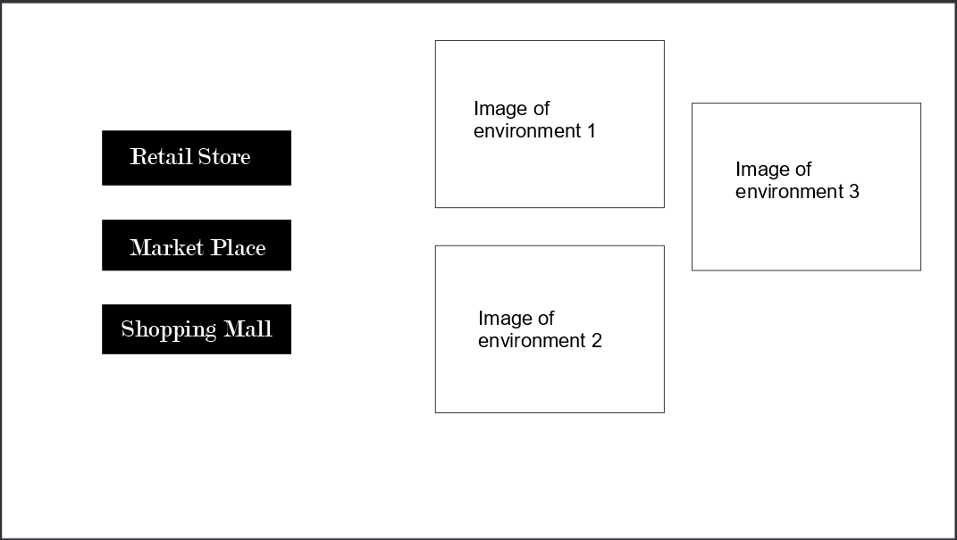

|  |  |  |
| --- | --- | --- |
| Test Plan | Nature of test | Example |
| To have an environment that is variable, and changes based on the client's preferences for the patient | The environment has scalable noise factor, animal presence, and lighting | Noise: < 1 >  Brightness: < 1 >  Light intensity: < 1 >  Animal population density: < 1 > |
| The client can download and use the game on multiple devices. | When the client accesses the portal where the different download files are stored, they can choose between IOS, Android, Windows, and Mac. | Zip.Mac  Zip.Windows  Link to Mobile downloads |
| Have a functioning interaction system | When the patient starts the game and enters an environment their actions influence the environment. | Press E to open door |
| The client can pick which environment they want to be in | When on the menu’s the client can select between different environments depending on their specifications. | Environment 1: Market place Environment 2: Retail store  Environment 3: Sopping Centre  Select the desired environment |
| The client can increase or decrease the amount of npc’s in the environment | When setting up the environment the client can use a slider to change the quantity of npc density they want in the game | Npc count: < 10 > max: 200  Npc variety: < 3 > |
| The client can exit the game at any point and return to the menu for any subsequent patient | When the client is in the game, and they wish to move to another patient they can go to the pause menu and select return to menu and go back to the menu screen. | PAUSE MENU  Return to Main Menu |
| The client or patient should be able to pause or exit the game when they wish | As the patient is going through the game and there is instant need to leave the game for any odd reason, then there is a clear leave game button one they go into the pause menu | PAUSE MENU  Return to Main menu  Exit Game |
| The client and the patient can recognize the environment as realistic representations | The client and patient will be able to recognize different aspects of each environment as they traverse through it | Client observations:  Tree with birds inside  A lamppost with lighting |
| The client can recognize a reduction in agoraphobia following the use of the video game | As, client conducts more uses of the game they can record a definitive decrease in anxiety levels when t comes to external environments | Client Observations:  Day 1: Patient is quite stressed and is struggling to adapt  Day 2: The Patient is starting to show signs of willingness to get better.  Day 3: ... |

Evaluation: Needs to be reused to demonstrate significant reduction in anxiety related behaviors